

Job profile

Job title: Book Fair Manager

Job goal: To oversee the Business School team in planning, promoting and running the Book Fair to ensure the greatest success for your school

Positions available: Two [change this to meet the needs of your school]

Key responsibilities:

- Set up a brainstorm meeting with the volunteer team to share ideas and agree the plan and goals for the Book Fair

- Assign tasks to others and ensure that they are completed on time at regular meetings

- Create a roster so that all volunteers know when they are needed to help at the Book Fair

- Offer support to other volunteers if needed and listen to their thoughts about the project and their roles

- Co-ordinate your entry to the Scholastic Business School of the Year Award by taking photos, making notes and/or conducting interviews

Skills and qualities required:

- Strong organisational abilities
- Excellent communication skills
- Works well within a team

Job profile

Job title: Advertising Specialist

Job goal: To spread the word about the Book Fair to students, parents and the wider community using a variety of methods

Positions available: Four to six [change this to meet the needs of your school]

Key responsibilities:

- Plan ways to make sure that everyone knows when the Book Fair will take place using websites, newsletters, social media and more

- Make advertising materials to spread the word and/or use the materials supplied by Scholastic Book Fairs

- Build excitement before the Book Fair arrives by starting a countdown in assembly and sending letters, leaflets, newsletters and/or text messages to parents and students

- Announce the Book Fair’s imminent arrival by putting up posters and arrows

- Display a goal chart clearly at the Book Fair and update daily with your progress

- Take down any advertising material afterwards and send letters to let parents know about the Book Fair’s success

Skills and qualities required:

- Strong creative skills, especially with words and/or pictures
- Ability to think up inventive, exciting and entertaining ideas
- Confident communicating with other pupils, parents and teachers
- Works well within a team

Job profile

Job title: Customer Service Assistant

Job goal: To help Book Fair customers with their purchases and enquiries in a pleasant, polite and efficient manner

Positions available: Six to eight [change this to meet the needs of your school]

Key responsibilities:

- When the Book Fair arrives, set up a cash desk with calculator, pens, sales record sheets, customer reorder sheets, stock list etc. and ensure it is tidy, safe and easy for customers to access

- Familiarise yourself with the books available and their prices so you can help customers with their enquiries more efficiently

- Take customer payments in cash, cheque or gift vouchers and accurately record all sales information

- Liaise with Accountants to ensure that all monies are safely and correctly counted and stored

- Take payment and details of all customer reorders and liaise with Inventory Specialists to ensure that they are ordered correctly from Scholastic Book Fairs

Skills and qualities required:

- Confident working with numbers and handling money
- Methodical and responsible when recording details
- Polite and friendly attitude to put customers at ease
- Works well within a team

Job profile

Job title: Accountant

Job goal: To oversee the money-handling process and calculate the Book Fair takings

Positions available: Six to eight [change this to meet the needs of your school]

Key responsibilities:

- Work out the float and different coins/notes needed at the Book Fair to be able to give customers the correct change

- Liaise with Customer Service Assistants to ensure that all sales, order and payment information is accurately recorded

- Calculate the daily takings at the Book Fair by counting up the sales and reorder records and cross-check with the actual takings

- Communicate the daily and final takings to Advertising Specialists so that they can update the goal chart to show your progress

- Work out how many free books the school has earned by completing the cash report form on Scholastic Book Fairs’ website after the Book Fair has been collected and all customer orders placed

Skills and qualities required:

- Confident working with numbers and handling money
- Methodical and responsible when recording details
- Attention to detail

Job profile

Job title: Display Specialist

Job goal: To create a pleasant, friendly and fun environment for Book Fair customers to visit

Positions available: Two to four [change this to meet the needs of your school]

Key responsibilities:

- Create a diagram to show the Book Fair’s location within the school and how the bookcases, poster box, stationery box and cash desk will be safely laid out

- Plan how to decorate the Book Fair using balloons, bunting or other colourful, fun materials. You may wish to choose a theme to decorate your Book Fair such as pirates, rainforest or dinosaurs

- Create special displays of highlight books to catch a customer’s eye e.g. a table collecting bestsellers, bargain books or a range of books on a similar topic

- When the Book Fair arrives, set up and decorate the area, put up the headerboards on the back of the bookcases and ensure that the displays are kept tidy throughout.

- Take down any decorations and help to pack up after the Book Fair has finished

Skills and qualities required:

- Strong creative skills
- Ability to think up inventive, exciting and entertaining ideas
- Attention to detail
- Works well within a team

Job profile

Job title: Events Coordinator

Job goal: To create excitement at the Book Fair by running a competition and other fun events

Positions available: Two to four [change this to meet the needs of your school]

Key responsibilities:

- Plan special events such as a fancy dress day, a raffle, storytelling activities or an official Book Fair opening ceremony involving the Principal, special guest from the community or a character costume (can be hired from Scholastic Book Fairs)

- Create excitement before the Book Fair by running a competition to involve the whole school. Visit scholastic.com.au/bookfairsonline for suggestions or come up with your own ideas

- Download a book voucher to give as prizes to the competition winner or winners by visiting scholastic.com.au/bookfairsonline before the Book Fair arrives

- Collect the competition entries to create a display at the Book Fair and invite parents to come and see. Choose a competition winner or winners and award the prize vouchers

Skills and qualities required:

- Strong creative skills
- Confident communicating with other students, parents and teachers
- Ability to stick to deadlines
- Works well within a team

Job profile

Job title: Browsing Supervisor

Job goal: To organise browsing sessions for all students to visit the Book Fair during the school day

Positions available: Four to six [change this to meet the needs of your school]

Key responsibilities:

- Create a timetable so that each class has a set time to visit the Book Fair to browse and distribute the approved timetable to all teachers

- Ensure that there are enough activity wishlists to give one to each student (these will be sent four weeks before the Book Fair). Download more if required from scholastic.com.au/bookfairsonline

- When the Book Fair arrives, familiarise yourself with the book selection so that you can help younger children with their choices

- Decide who is responsible for collecting and returning each class on time and who will supervise the distribution of activity wishlists, ensuring that they are filled in and taken home afterwards

- Ensure that the books and displays are tidy at the end of each session

Skills and qualities required:

- Keen interest in books
- Good communication skills
- Assertiveness and ability to stick to deadlines

Job profile

Job title: Inventory Specialist

Job goal: To monitor bestseller stock and ensure that customers receive their orders

Positions available: Two [change this to meet the needs of your school]

Key responsibilities:

- Plan how to promote bestselling titles by liaising with Display Specialists to create book displays

- Download and print last copy bookmarks to put in only the bestselling titles so that customers can order copies of books that may be low on stock. Last copy bookmarks can be found at scholastic.com.au/bookfairsonline

- Monitor stock daily to see what the bestsellers are and ensure that customers can place orders for these

- Liaise with Customer Service Assistants to ensure that customer orders are correctly noted and collected at the end of each day

- Contact Scholastic Book Fairs to place all customers orders before the Book Fair is collected and arrange for the books to be delivered to customers once they arrive

Skills and qualities required:

- Attention to detail
- Good communication skills
- Strong organisational abilities

Volunteer here!

We’re looking for buzzing business minds, magical maths whizzes, dazzling design gurus and friendly front-of-house specialists to plan and run our next Book Fair!

Everyone has a vital part to play, so have a look at the jobs listed below and decide which one most appeals to you.

Fill in an application form or complete a CV and cover letter and hand in to [insert teacher name] by [insert closing date]. Remember to really sell yourself as there may be lots of competition for each job. Best of luck!

Job title | Positions available | Key responsibility and required skills
Book Fair Managers | 2 | Oversee the Business School team in planning, promoting and running the Book Fair. Must be organised, responsible and a good communicator.
Advertising Specialists | 4 - 6 | Spread the word about the Book Fair to students, parents and the wider community. Must be creative and work well in a team.
Customer Service Assistants | 6 - 8 | Help Book Fair customers with their purchases and enquiries in an efficient manner. Must be polite, responsible and confident handling money.
Accountants | 2 | Oversee the money-handling process and calculate the Book Fair takings. Must be methodical and confident working with numbers/money.
Display Specialists | 2 - 4 | Create a pleasant, friendly and fun environment for Book Fair customers to visit. Must be creative and work well in a team.
Events Coordinators | 2 – 4 | Create excitement at the Book Fair by running a competition and other events. Must work well in a team and be able to stick to deadlines.
Browsing Supervisors | 4 – 6 | Organise browsing sessions for all students to visit the Book Fair. Must be responsible and a good communicator with an interest in books.
Inventory Specialists | 2 | Monitor bestseller stock and ensure that customers receive their reorders. Must be organised and responsible.


Application Form

Name
Age
Class
Job(s) you are applying for
Why you would like this job
School skills and interests | (List the 3-5 school skills and subjects you are very good at, in bullet points; for example, sports or doing history projects)
School teams and responsibilities | (List the responsibilities you have had in school and any clubs or teams you have been in, in bullet points; for example, library monitor or wildlife club)
Other hobbies and responsibilities | (List the things you like to do in your spare time and any chores or responsibilities you have at home, in bullet points; for example, helping to clear the table every day or taking the dog for a walk)
Name of referee | (Give the name of an adult who knows you well and is happy to recommend you for the job)

Sarah Evans
Year 5, Oak class
Greenhill Primary School, Bideford

School Skills and Strengths

- Numeracy skills
- Reading
- Drawing, painting and designing and making models
- Swimming

School Responsibilities and Achievements

- Library monitor (years 3, 4 and 5)
- Art monitor (years 4 and 5)
- On the swimming relay team (year 5)
- Helped with Red Nose Day event (year 5)

Hobbies and Other Responsibilities

- Drawing and painting
- Looking after my sister and helping her with her reading
- Feeding, cleaning and looking after my rabbit

(Your name)
(Your year and class)
(The name of your school)

School Skills and Strengths

(A list of the 3-5 school skills and subjects you are very good at, in bullet points; for example, sports or doing history projects)

School Responsibilities and Achievements

(A list of the responsibilities you have had in school and any clubs or teams you have been in, in bullet points; for example, library monitor or wildlife club)

Hobbies and Other Responsibilities

(A list of the things you like to do in your spare time and any chores or responsibilities you have at home, in bullet points; for example, helping to clear the table every day or taking the dog for a walk)

Oak class
Greenhill Primary School
Main Road
Bideford

4th March 2017

Dear Mrs Braithwaite

I would like to apply for the display specialist position in this year’s Scholastic Business School. My school and outside responsibilities have given me the necessary skills to fill this role with enthusiasm and competence.

My imaginative art and design skills have been used at school for posters and events. Since starting year 5, my paintings have been displayed in the corridor and classroom wall and I have also created posters and small props for the Christmas play and Red Nose Day event.

I am responsible and reliable. Throughout years 4 and 5, I have acted as art monitor, helping Miss Rose to lay out all art supplies for class activities and making sure that the art cupboard is always tidy. At home, I make sure that my rabbit is always fed and that her hutch is always clean.

I look forward to hearing from you.

Yours sincerely

Sarah Evans
Oak class (year 5)

(Your class)
(Your school’s address)

(Today’s date)

Dear (Name of the person in charge of the Business School)

(Give a short introduction to your letter; you could write one sentence saying which job you would like to apply for, and a second sentence saying why you would be good at this job)

(Look at the skills section of the job profile and write a paragraph for each skill, showing how you have shown this skill; for each paragraph, start with one sentence to say that you have the skill and then a second sentence to give an example of where you have shown or used this skill)

(End with one sentence to close the letter; you could say that you are looking forward to hearing from him/her, or you could thank him/her for considering you for the job)

Yours sincerely

(Your name)
(Your class and year)


Book Fair staffing roster

• Write the names of volunteers who are staffing the Book Fair in the time slots below. They can help to take payments and orders, help with enquiries and keep the bookcases tidy.
• Put the roster up in classrooms and hand out to volunteers so everyone knows their allotted time.

 | Book Fair session | Opening time | Monday | Tuesday | Wednesday | Thursday | Friday
Week 1 | Before school | 8.00 – 8.30
 | After school | 15.00 – 16.00

 | Book Fair session | Opening time | Monday | Tuesday | Wednesday | Thursday | Friday
Week 2 | Before school | 8.00 – 8.30
 | After school | 15.00 – 16.00

Timings listed are suggestions only.


Accountant

…………………………………
Customer Service

…………………………………
Book Fair Manager
……………………………………

Advertising Specialist
……………………………………

……………………………………

……………………………………

Display Specialist

…………………………………
Events Co-ordinator

…………………………………
Browsing Supervisor

…………………………………
Inventory Specialist

…………………………………

Dear parent or carer,

We’re looking for buzzing business minds, magical maths whizzes, dazzling design gurus and friendly front-of-house specialists!

Over the next six weeks, (name of class or year group involved) will be running Scholastic Business School. Our aim is to teach students about the world of work by letting them plan and run our Scholastic Book Fair, which will take place between
(Fair start date) and (Fair end date).

Students are encouraged to demonstrate responsibility, show initiative and use problem-solving skills by each taking on a specific ‘job’ within the running and planning of the Book Fair. They will be given job profiles over the coming weeks – from accountants to display specialists, managers to browsing supervisors – and we will invite them to apply for the jobs that interest them by submitting an application form/a CV and cover letter by (applications deadline).

We hope that you will take the time to come along to the Book Fair to view the books on offer and to see the students’ Business School at work! The Book Fair will be open for half an hour before school and an hour after school between (Fair start date) and (Fair end date) and each class will also have a chance to browse the shelves during school time. The Book Fair is a great way for us to earn free books and resources, so the more the Business School team sells, the more free books for (school name)!

Thank you for your support. If you or your child would like to discuss the Business School or upcoming Book Fair, please speak to our Book Fair Organiser, (name of Book Fair Organiser).

Yours sincerely
Class browsing sessions rota

• Write each class name in the relevant time/day slot along with the name of the volunteer who is responsible for collecting, assisting and returning the class.
• Hang the roster in the staff room and give to each class’s teacher so that they know their visiting time. You could also invite parents if appropriate.
• Don’t forget to hand out Student Wishlists to get children exploring the books and choosing their favourites.

 | Monday | Tuesday | Wednesday | Thursday | Friday
9.00 – 9.30
9.30 – 10.00
10.00 – 10.30
 | B | R | E | A | K
11.00 – 11.30
11.30 – 12.00
 | L | U | N | C | H
13.00 – 13.30
13.30 – 14.00
14.00 – 14.30
14.30 – 15.00

Timings listed are suggestions only – we recommend at least 20 minutes for each class browsing session.

Sales record sheet

Write down the title of each book sold and how much was paid it as a way to measure how your Book Fair is going. If a customer wishes to place an order, please use the customer orders record sheet.

Title of book | Price ($) | Paid?  Tick if ‘yes’

Total for this page: _______________

Customer orders record sheet

Use this sheet to take orders for books that may not be in stock at the Book Fair. Note down the customer’s name, class, the title of the book and how much they paid. Let Scholastic know before the last day of your Book Fair and the titles will be delivered when the Book Fair is collected. Tick off orders as they are delivered to customers.

Customer name | Class | Title of book | Price ($) | Paid?  Tick if ‘yes’ | Order delivered? Tick if ‘yes’

Total for this page: ____________

Cashing up sheet

• Print several copies and ask multiple volunteers to count the takings to ensure accuracy.
• Compare the grand total with the totals from the sales record/customer order sheets to see if they tally.

Name: __________________________________________________ Date_______________

Denomination | Total ($)
5c coin | $ .
10c coin | $ .
20c coin | $ .
50c coin | $ .
$1 coin | $ .
$2 coin | $ .
$5 note | $ .
$10 note | $ .
$20 note | $ .
$50 note | $ .
$100 note
Cheques | $ .
Total cash and cheques | $ .

Total gift vouchers | $ .

Total cash, cheques and  gift vouchers | $ .

Float (subtract from above) | $ .

GRAND TOTAL | $ .

Signed (volunteer):______________________ Signed (teacher): ______________________

Volunteer evaluation survey

Name: ___________________________________________ Date: _______________

About You

1. What was your job title? _________________________________________________

2. List three things you did as part of your job:

- ____________________________________________________________________

______________________________________________________________________

- ____________________________________________________________________

______________________________________________________________________

- ____________________________________________________________________

______________________________________________________________________

3. Give an example of how you were able to use your initiative during your work:

________________________________________________________________________

________________________________________________________________________

4. Give an example of how you solved a problem during your work:

________________________________________________________________________

________________________________________________________________________

5. How effective do you think you were at your job? (Circle the best answer)

Very effective Sometimes effective Not very effective

6. Score how much effort you put into your job, with 1 being very little effort and 5 being a lot of effort:

1 2 3 4 5

7. Were there any things you could have done differently/better?

________________________________________________________________________

________________________________________________________________________

8. Score how well you think you worked as part of a team, with 1 being ‘not very well’ and 5 being ‘very well’:

1 2 3 4 5

9. What did you learn from experiences from working at the Book Fair?

________________________________________________________________________

________________________________________________________________________

10. Did you enjoy working as part of Scholastic Business School? (Circle your answer)

Yes No

11. Would you recommend the experience to other students?

Yes No

About your team

12. Score how well you think the team worked together, with 1 being ‘not very well’ and 5 being ‘very well’:

1 2 3 4 5

13. Was there anyone who you think performed outstandingly well during the project? If so, give their name and your reasons below.

________________________________________________________________________

________________________________________________________________________

14. Was there anyone who you think didn’t put much effort into their job? If so, give your reasons below.

_______________________________________________________________________

________________________________________________________________________

15. How effective do you think the leadership was?

Very effective Sometimes effective Not very effective

16. If your team had a manager or managers, do you think it helped you to do your job better? Please give your reasons below.

_______________________________________________________________________

________________________________________________________________________

17. Did you have any setbacks or problems with running the Book Fair as an enterprise project? Please give your reasons below.

_______________________________________________________________________

________________________________________________________________________

18. Overall, how successful do you think the project was?

Very successful Moderately successful Not successful

Please give your reasons below.

_______________________________________________________________________

________________________________________________________________________

Thank you for completing the evaluation survey!

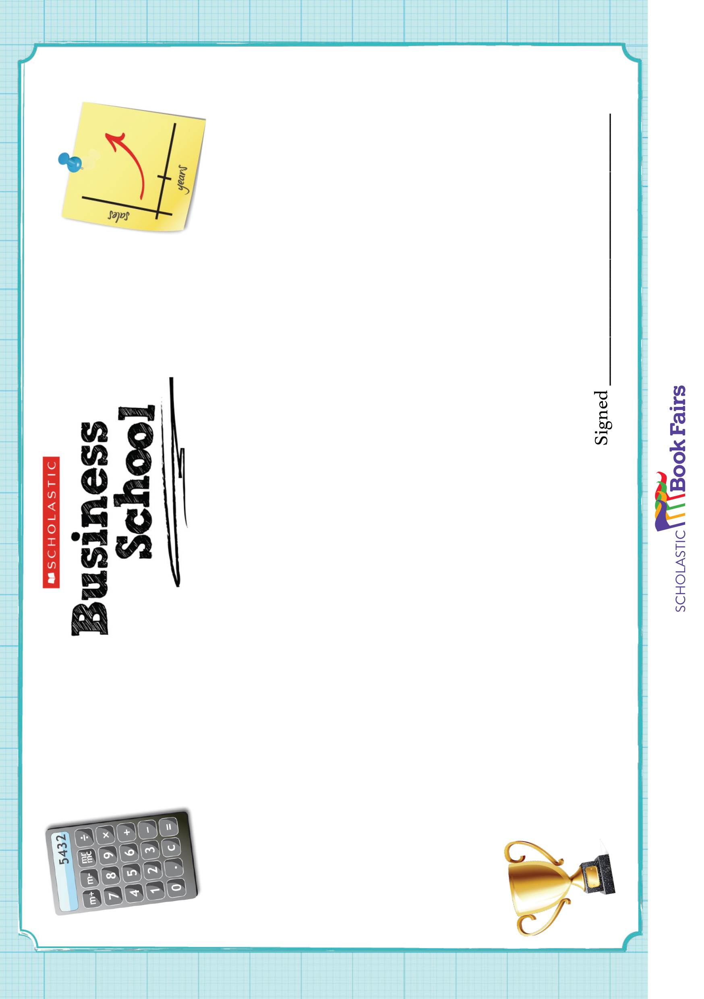

Dear parent or carer,

As you know, (name of class or year group involved) recently planned and ran our Book Fair as part of Scholastic Business School.

I’m delighted to report that the Business School was a huge success! The students were professional and responsible, running the Book Fair smoothly and selling a total of (number or value of books sold) books over the week.

We would like to thank all parents who took the time to encourage students through the Business School, and also those who visited the Book Fair itself. Thanks to the efforts of the Business School team and the parents who bought through the Book Fair, we will be able to buy (insert amount of Scholastic Rewards earned here) of new classroom books and resources for the school.

Most importantly, well done to (name of class or year group involved) for their hard work! We received lots of compliments about (detail of any outstanding element of Business School) and were particularly impressed by (further detail), but mostly by the maturity of all the students in working together to create a successful business team!

(Any further Business School details: pictures appearing in newsletter or on website; news item featured in local paper)

We are all looking forward to running the next Business School and will keep you updated on our plans!

Yours sincerely,

