

Dear Parent,

The best gift any parent can give a child is the love of books and the joy and benefits of independent reading for fun. Children who read at home, or are read to, have a head start on reading success in school.

Our class is participating in **Scholastic Book Club** this year. Up to twice a term, during the school year, I will send home a Club catalogue with a different selection of books offered for all ages.

You’ll find award-winning books and bestsellers, as well as old and new favourites. I recommend them because the books span a wide range of children’s reading levels and interests and because they are inexpensive (some books cost as little as $3).

It is easy to order. The **Book Club LOOP** platform for parents allows you to pay by credit card. Your child’s order is submitted directly to school safe and sound and the books will be delivered to class. You can place your child’s order at **scholastic.com.au/LOOP** or using the **LOOP** app, which can be downloaded from the App Store or Google Play.

Owning your own books is something special! I hope that you will encourage your child to order books this year. Each order helps earn free books and teaching materials for our classroom, however there is never any obligation to order. I know of no better way to encourage reading than to allow children to choose the books they want to read.

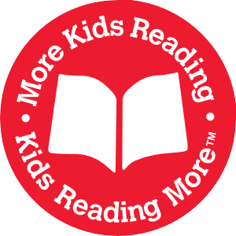Sincerely,

Your Child’s Teacher